B-C LEVEL
WEEK 8
TEACHER’S COPY
READING

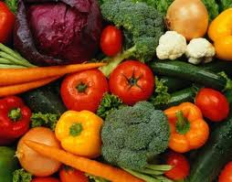GETTING INTO THE TOPIC

- Discuss the following questions with your classmates.

  - How important is food in your life? What does food mean to you?
  - Do you agree that if something tastes great, it is probably bad for you?

- What is more important: taste or nutrition?

- Read the paragraph and complete the chart.
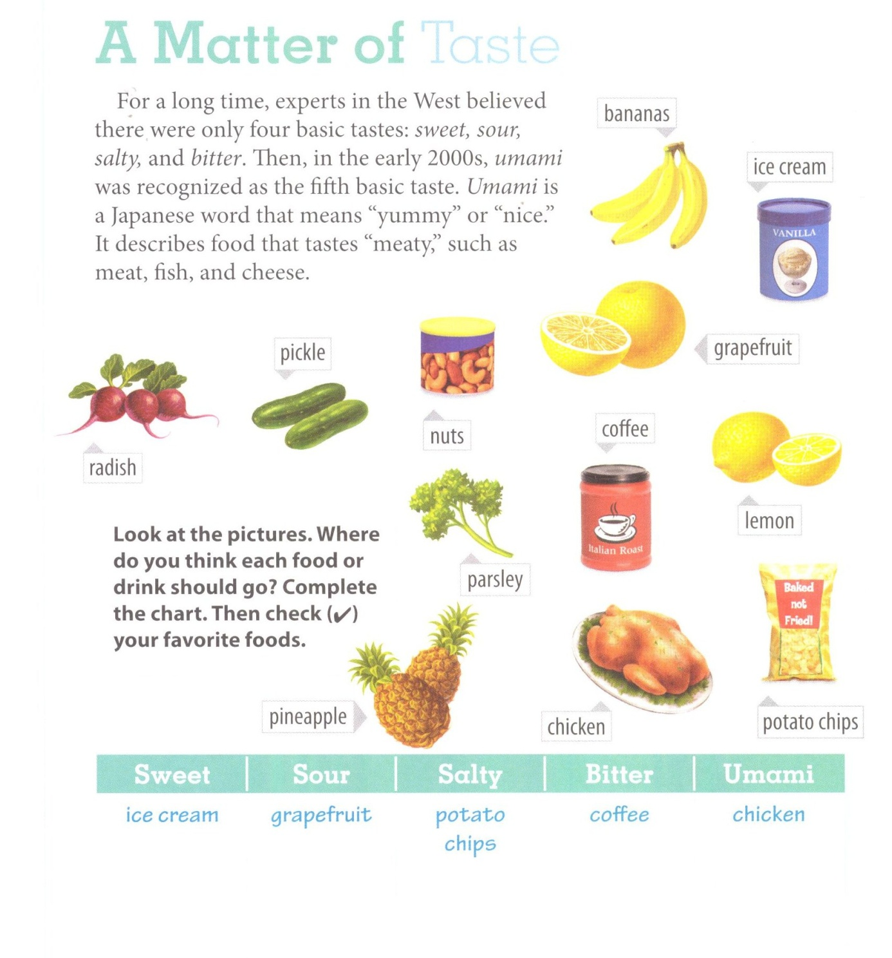

sweet | sour | salty | bitter | Umami /umami/
Pineapple  Banana  Ice cream | Lemon  Grapefruit  Pickle | Potato chips  Nuts | Coffee  Parsley  Radish | Chicken

- Tick your favourite foods in the chart. Which of the five basic tastes do you like best?

BECOMING ACQUAINTED WITH THE TEXT

- You are going to read an article from a health magazine about ways that we can eat well. Skim the text in three minutes by looking at the title, the picture, reading the first paragraph, subheadings, the 1st sentences of each paragraph and the final paragraph. Write answers to these questions.

- Does the author think science should help us choose the foods we eat?
No. the author doesn’t think science should help us choose the foods we eat. He
thinks common sense should.

- What suggestions for eating well do you think the author will talk about? Write as many as you
can.

  - ____________Answers will vary______________________________________________
  - _________________________________________________________________________________
  - _________________________________________________________________________________
3. The main idea of the whole text is that making healthy food choices and eating well are not difficult.

Eating Well:
Less Science, More Common Sense

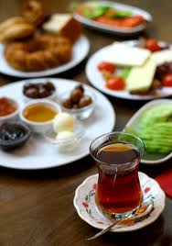1 Food is life. We eat food to grow, stay healthy, and have the energy to do everyday activities. Some of the food which we consume makes all of these things possible, but some do not. For example, studies have shown that children who eat a rich breakfast can concentrate longer, remember more, and participate more actively in class, whereas the students with a poor diet usually have problems with their lessons. Research has also shown that adults who have a healthy diet perform better on the job and miss fewer days of work. As a result, we can see that our food choices affect our health and behaviour, so we must do more than just eat; we must eat well. However, making healthy food choices is not easy for many people today.

2 There is a lot of information which tells us what's good for us and what isn’t. However, usually this information is more confusing than being helpful. In fact, different research about the same food often creates opposite results. Take one example: food studies done on eggs. For years, research showed a link between eating eggs and high cholesterol. Scientists advised us to limit or completely remove eggs from our diets so that dangerous illnesses like cancer or heart disease would be prevented. However, recent studies now say that eggs are actually good for you and that most people can - and even should - eat one a day. It's hard to know who to believe.

3 Shopping for food can also be challenging. We often need to make many different choices when we go to a supermarket. Should you buy this cereal or that one? Normal or fat-free milk? Meat or chicken? It is hard to know which to choose, especially when two items are very similar. Many shoppers read product labels to decide. Of course, people mostly buy items with the words "doctor recommended," "low fat," or "all natural" on them. But are these foods really better for you? Probably not. Indeed, many food labels are often misleading. For instance, doctors sometimes recommend that people should eat yogurt for their digestion, related to this a yogurt company might use the label "doctor recommended" and you buy their product. In reality, although their specific yogurt isn't preferred by doctors, shoppers may think it is because of the food label.

4 So how do we make healthy choices? Prof. Michael Pollan (the University of California, Berkeley) has written many books about eating well (including the bestseller “In Defense of Food”). In his opinion, our food should be prevented from the "unnecessary stress” caused by "nutrition science and the food industry.” According to Pollan, we should stop reading labels and listening to the scientific experts. Instead, he offers some simple and practical tips for eating well and staying healthy.

5 Tip 1: "Eat a balanced diet, but mostly plants." In other words, only eat "real food" which your great-grandparents would name as food. Make fruit and vegetables your main source of food and limit the amount of meat you eat. Eat well, but not too much. Prof. Pollan quotes the Okinawan people of Japan who have an expression: "Here Hachi Bu: eat until you are 80% full."

6 Tip 2: "Get out of the supermarket whenever possible.” Shopping for meat or dairy products at the market is okay; on the other hand a supermarket is also full of items like noodles, diet sodas, and similar products - the ones that aren't good for us. Instead, try to shop at a farmers' market or a local store. The food there is fresher and healthier.

7 Tip 3: Pollan says that eating is not only about physical health and nutrition. "Food is also about pleasure, about society and family." Learning how to cook and sharing a meal with others are obviously important parts of eating well and being healthy.

8 In addition, the third tip is helping people to reconnect with food traditions. In cities around the world, for example, urban gardens which were common in the past are becoming popular again, where neighbours are working together to grow fruit and vegetables. There are several advantages of these gardens. First, people have access to more fresh fruit and vegetables, especially poorer people who cannot spend enough money on these items. Second, the food costs less than it would in a supermarket. Furthermore, working together in the garden helps people to exercise, and finally it supports community and sharing. This will help you have a happier mood.

9 Urban gardens have been used to teach children about food production and healthy eating. They attract their attention very much. At the Edible Schoolyard - a program at a public school in the U.S. - children learn how to plant and pick up fruit and vegetables. They learn how to clean and prepare them for meals - a skill that they will be able to use all their lives. They like learning healthy eating habits, they want to eat the things they have grown. These gardens are getting popular day by day.

10 In conclusion, making healthy food choices and eating well are not difficult. Be wise and do simple things. Changing your shopping habits, learning to cook, planting a garden, and limiting your eating of certain foods can result in a better diet and a healthier you. Bon appétit!

- Read the statements. Would the writer of the magazine article agree with them?
Write “Y” (yes) or “N” (no).

__N__ 1. Scientific research about diet and health usually gives us helpful information.
__N__ 2. Reading food labels has made us better informed, healthier consumers.
__Y_ 3. We don’t need experts to tell us what to eat.
_ Y__ 4. A lot of food found in a supermarket is not “real food.”
_ N__ 5. The purpose of eating is mainly for health and nutrition.
__Y__ 6. An urban garden is an old tradition that works well in modern cities.

LOOKING FOR DETAILS

- Answer the questions according to the reading text.

- According to the reading, which question is difficult for many people to answer today?

  - Why do some people have a healthier diet than others?
  - How does your diet affect our health and behavior?
  - Which are the healthiest foods to eat?

- In paragraph 2, the studies on eggs are an example of ____ from the scientific community.

  - confusing results
  - helpful advice
c) similar findings

- Food labels that read “low fat” or “all natural” ____.

  - are usually on products recommended by doctors
  - are primarily used to sell a product
  - often help shoppers make healthy food choices

- Which piece of advice would Michael Pollan probably agree with?

  - Try to eat only one meal per day; you’ll feel better and be healthier.
  - Selecting healthy food and learning how to cook it are both important.
  - Never shop at a supermarket; the food there is unhealthy.

- At the Edible Schoolyard in the U.S., what are children not learning to do?

a) Plant fruit and vegetables.
b) Cook and eat healthy meals.
c) Read and understand nutrition labels.

VOCABULARY STUDY

- Match the words with their meanings.

- Consume __d____ a) effective or successful
- Confusing _ _f____ b) easily noticed, seen
- Practical __a____ c) the way you are feeling
- Obviously __b____ d) eat or drink
- Mood __c____ e) sensible in making decisions
- Wise __e____ f) unclear, difficult to understand

- Fill in the blanks with one of the suitable words below.

mood | practical | obviously
consume | wise | confusing

- Eating a large meal before you go to bed isn’t very _ practical ____________. It won’t be a useful thing if you want a good sleep.

- People _ consume ____________ too much water today. If they continue wasting this important resource at this rate, we won’t have enough of it in 10 years time.

- You look very depressed nowadays. You should try to change your _ mood ____________ and be a bit more relaxed. Otherwise, this feeling will affect your health badly.

- It was very clear that Merdivenspor lost the match, because its supporters were obviously _ sad while leaving the stadium.

- A _ wise _______________ person is clever and makes logical decisions in any case.

- To stay with her family or go abroad became a really _ confusing ____ situation for Mary and seemed hard to decide.

